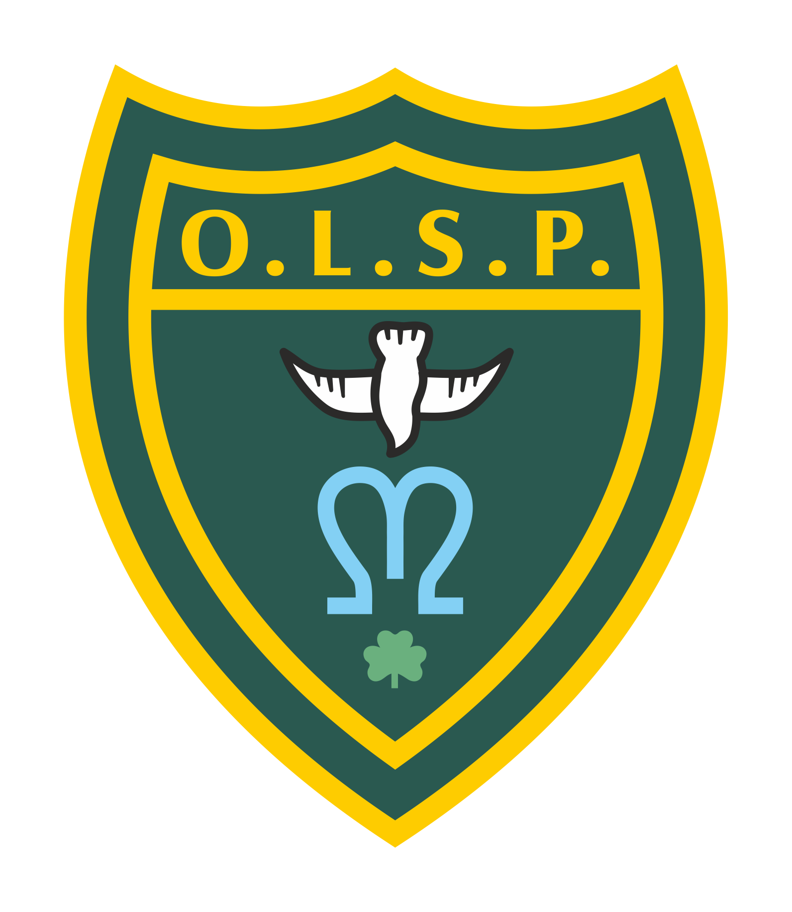
Our Lady and St Patrick’s RC Primary School

Summer 2 Curriculum Newsletter

Class 3

 | Teacher’s Message | Hello All and a big welcome back. Hope you all enjoyed half term off and managed to get out to celebrate the Queen's Jubilee while dodging the rain.
 | Homework | Set on Google Classroom:  Spellings: Weekly spellings are set on Spelling Shed each Friday. Each week, the children receive a list of 10 words which will focus on practising new spelling rules.  - Weekly spelling tests take place on Fridays.  - Please make sure children are practising spellings daily where possible.  Maths: IXL activities linking to our classroom learning.  Please also practise TTRockstars for times tables. There will be a weekly rockstar on display in class.  English/Reading: A writing based task linked to the weekly spellings will be set. Children should also bring home their AR books from school and try to read daily for at least 5 minutes. They can then quiz on these in school.  Homework will continue to be set on Class dojo on a Friday after school and be due the following Friday. I will print out sheets for children to also practice their handwriting.
 | Reading for Pleasure | We are still currently reading through Mr Penguin and the lost treasure by Alex Smith. ‘Meet Mr. Penguin: adventurer. He has a dashing hat. A battered satchel. And a kung-fu spider sidekick. Now he just needs an adventure!’  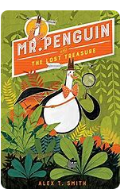
 | English | In English we are going to be looking at a text called ‘The Whistling Monster.’ which is a short story by Jamilia Garvin. We will be picking it apart for its use of speech, adverbial phrases and its structure to support our own creative writing.
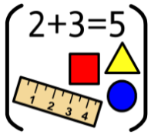 | Maths | In our maths lessons this half term we will be continuing Fractions. The children have shown great enthusiasm for fractions and have taken to it really well. We’ll be looking at finding fractions of numbers and objects as well as adding and subtracting fractions from each other.
 | RE | In RE we are learning about Reconciliation with a focus on making choices. We will look at the choices we make and the consequences as a result of those choices. We will look at the importance of conscience in making choices and being able to apply ourselves and relate the above to our own lives and celebrating good choices.
 | Science | In Science we are learning about states of matter and the water cycle. Children will be looking at the connection between solids, liquids and gases and questioning the importance of every phase of the water cycle and its impact on the world.
 | Music | In Music we will be learning to identify a piece’s structure: Intro, verse, bridge, chorus, introduction, verse, bridge, chorus.  Identify the instruments/voices: Keyboard sounds imitating strings, a glockenspiel playing as a keyboard, electric guitar, bass, drums.  Find the pulse whilst listening and perform and share
 | History | In History we will be learning about Vikings and asking the questions how do people react to invasions? Looking at why the vikings chose to invade Britain and what happened to the monarchy at the time? Britain under biking rule and ultimately if the viking invasion benefited Britain or not.
 | RSHE | In RSHE we will be looking an individual’s relationship with the wider world. Here we explore how human beings are relational by nature and are called to love others in the wider community through service, through dialogue and through working for the Common Good:
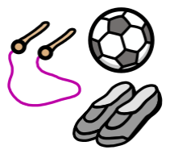 | PE | In PE this term we have the pleasure of having a sports coach come in and support me in teaching Lawn Tennis lessons approved by the Lawn Tennis Association. Orr PPA PE will be covered by the South Dartmoor Partnership and they will be teaching the children Cricket as we come into the glorious summer months.
 | Computing | In Computing the children will be continuing database work and looking at spreadsheets and recording and interpreting data on google sheets. Using the theme of a ‘Comparison cards game’ (based on the popular game, Top Trumps), to understand what a database is by learning the meanings of records, fields and data. Further exploration will lead to the development of the ideas of sorting and filtering.
 | Spanish | In Spanish this term the children will be learning colours and numbers in Spanish and by the end of the unit they should be able to:  Name and recognise all ten colours presented in the unit.  Name and recognise the numbers 1 - 10 in Spanish.  Spell most or some of the colours and numbers from 1 - 10 in Spanish.
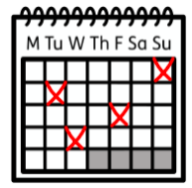 | Upcoming dates/events | Wednesday 8th June - World Oceans Day - Our Eco Rangers will be communicating some exciting plans for this day to raise our awareness of climate change on our oceans.  Friday 10th June - Year 6 are running a Jubilee Street Party - more details to follow. (Please reserve the date)  Thursday 16th June - Friends Father’s Day Gift Shop  Fridays from 17th June - Lawn tennis coaching for Year 3  17th June - Year 5 and 6 cake sale  22nd June - Sports Day  23rd June 5:30pm - Final heat of the Key Stage 2, Teignmouth Rotary Club, ‘Junior Speaks’ competition  Friday 24th June - St Aloysius Day . £1 donation to wear yellow, blue and white for the Catholic Children’s Society  28th June 7pm - Charity Bingo Night in aid of OLSP Friends @ Teignmouth Social Club.  Thursday 7th July pm - We will be inviting children to meet their teacher for September this afternoon.  11th, 12th, 13th July - OLSP has talent  Tuesday and Wednesday 19th & 20th July - Moving Up Day in school
 | Teacher contact: | jmason@olsp.uk  Please note that teachers are teaching from 8.30am - 3.15pm. If your contact is urgent please contact the school office office@olsp.uk during the school day.  There is no requirement for a teacher to reply to email or class dojo messages received after 6pm or at the weekend.

