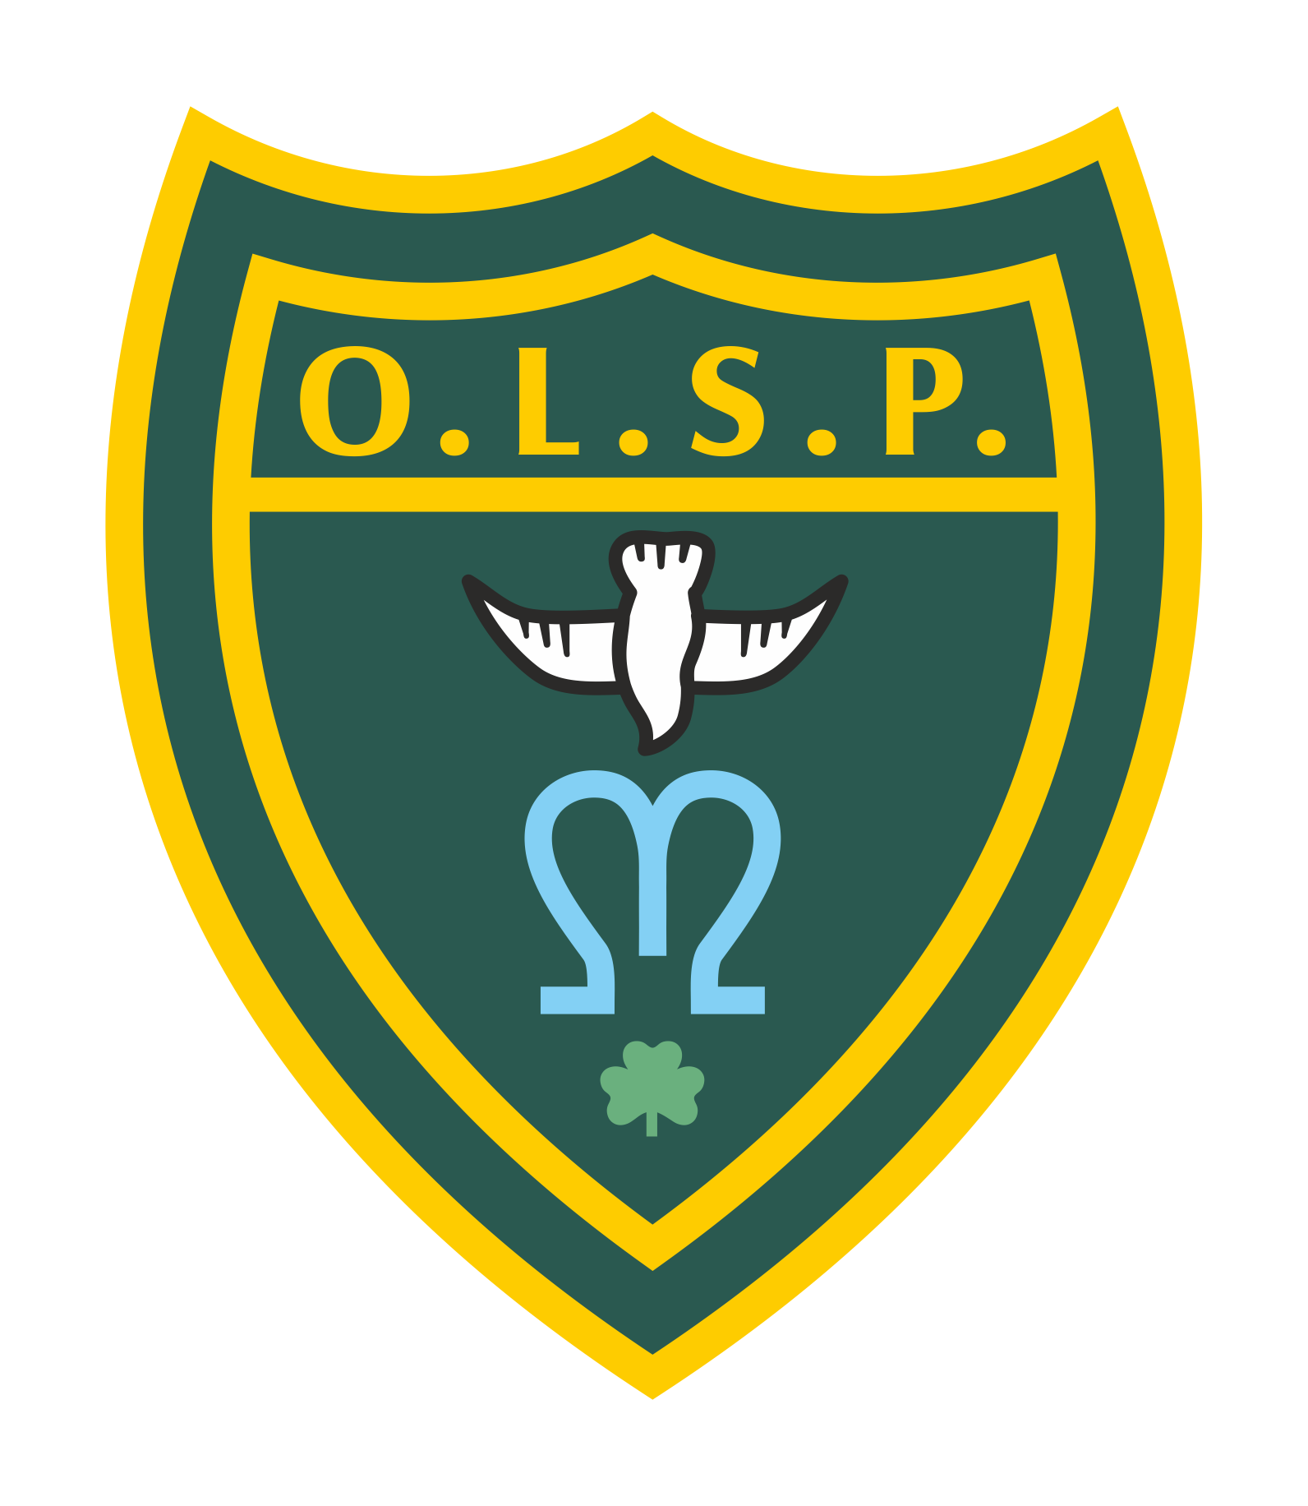
Our Lady and St Patrick’s RC Primary School

Half-termly Curriculum Newsletter

Class 5 Spring 2 ‘2023’

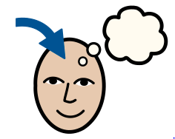 | Homework | Set on Google Classroom:  Homework is posted on Monday and the spelling test will be the following Monday.  English:  Weekly spellings are set each Monday. Each week, the children receive a list of 15 words which will focus on practising new spelling rules.  - Weekly spelling tests take place on Monday.  - Please make sure regular practice takes place.  Maths:  - IXL activities linking to our classroom learning with a focus on maths and grammar for the Spelling, Punctuation and Grammar SATs paper in May 2023.
 | Reading for Pleasure | This half term we will be reading  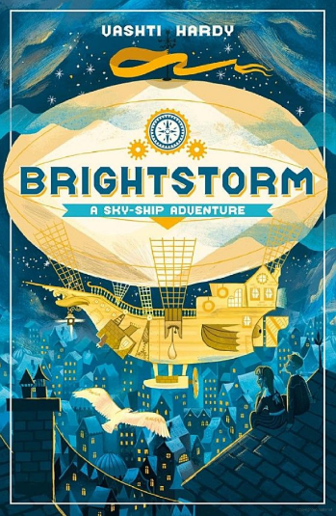
 | Writing | The writing focus will start with explanations followed by biographies. The first unit will focus on non-fictional writing in sequence developing the use of adverbial phrases, relative pronouns and the use of brackets. Our second unit will follow the same grammar developments using biographies.
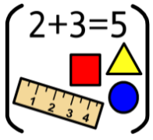 | Maths | This half term the children will be mainly focusing on fractions. This is a large unit where we will learn and develop understanding of equivalent fractions, mixed numbers, proper and improper fractions, adding and subtracting fractions.
 | RE | The children will continue with unity after half term. initially we shall examining the Eucharist is detail before reflecting on Lent.
 | Science | The focus for this half term is Earth and Space. The children will learn about Earth and its position in the solar system. We will examine day and night with a science week focus on sundials. Finally we shall learn about the phases of the moon.
 | Geography | This half term year 5 is investigating world climates, learning about climate zones, biomes and finally examining the impact of climate change.
 | D&T | The focus is mechanical structures. The children will be making a catapult out of lollipop sticks and we shall evaluate our product after a catapult competition.
 | RHE | This half term the children will continue learning money and how we spend our money with a an examination of ethical buying by learning about fair trade.
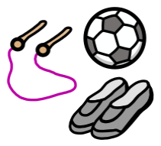 | PE | PE lessons will be held on Tuesdays and Fridays. The children will need to make sure their PE kit is in school.  The children will be learning how to play tennis and take part in dance lessons.
 | Computing | The children will continue learning about programming. They will learn how to decompose a program into an algorithm and learn how to write  algorithms for a purpose.  Our focus is on music, creating our own sounds for specific effect.
 | Teacher contact: | Class 6 Dojo Page.  Please note that teachers are teaching from 8.30 am - 3.15 pm. If your contact is urgent please contact the school office office@olsp.uk during the school day.  There is no requirement for a teacher to reply to emails or class dojo messages received after 6 pm or at the weekend.

