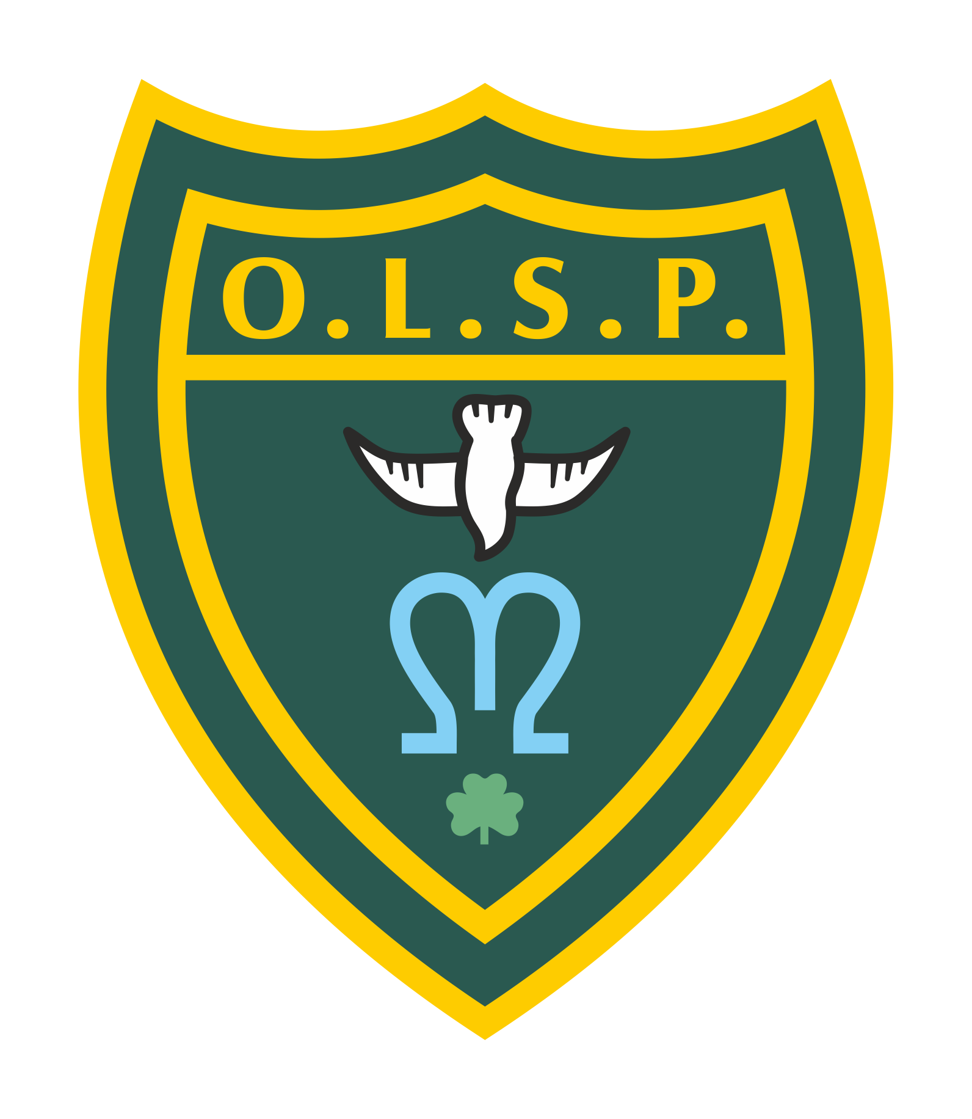
Our Lady and St Patrick’s RC Primary School

Half Termly Curriculum Newsletter

Class: 1 Summer 2

 | Teacher’s Message | Hello here is your half termly newsletter. I hope this update will give you a flavour of what we are going to be getting up to in class during Summer 2.
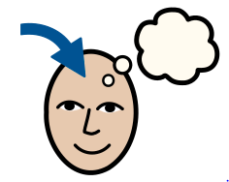 | Homework | Children will be receiving weekly homework on a Friday set on Google Classroom with a link also available on Class Dojo. Each child will be given a handwriting / spelling task, a maths task on iXL that will be linked to the learning in class that week.  The first week of each half term there will also be a research based project linked to a foundation subject focus. This can be completed at any time during the half term and provides an opportunity for children to deepen their understanding in a different curriculum area.
 | Reading for Pleasure | The children are doing an amazing job of reading and we have so many children on AR now. I hope we can continue this, this half term to really instil the love and need to be good readers. We are going to the library every week where all the children will get the opportunity to pick a book to share with you at home. In class we will be continuing with having an author in focus this half term it will be Jill Murphy.
 | Reading | The children continue to have phonics in their separate groups each morning. They will be bringing home a book-bag-book related to the sound/ focus in their group each week. We recommend you try and read with your child 3-4 times a week to build their confidence and fluency. We are aware after a few times of reading it can seem repetitive but this is an opportunity for the children to practice there inference skills and 'storyteller voices’
 | Writing | This half term we will be going on a trip to the Princess Theatre this will help us write our main piece which will be a recount of an experience. Skills involved will include writing in past tense, descriptive language and writing in first person.
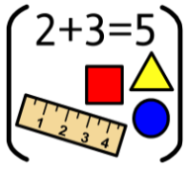 | Maths | In maths we will be moving on to numbers to 100! We will continue to explore times tables (2s, 5s and 10s) and exploring different manipulatives. We will be taking a little look at fractions, time and money.
 | RE | In this half term our focus will be on being sorry and looking at good and bad choices. We will look at things to do if you have made a bad choice and how to fix it and how to celebrate a good choice.
 | Geography | In Geography we will be looking at local geography looking at the coast and our beaches locally.  We will be looking at human and physical effects of our local areas.
 | Art | In Art looking at natural forms and artists like Georgia O’Keeffe and Lucy Arnold. Focusing on our observational skills and creating close-up detailed drawings of things like leaves, flowers shells etc with different drawing materials.
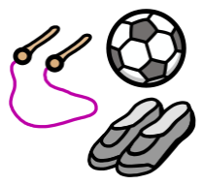 | PE | In PE we will be looking at competitive games and looking at the importance of rules and why they are needed.
 | Science | In science we will be describing how animals obtain their food from plants and other animals, using the idea of a simple food chain, and identify and name different sources of food.
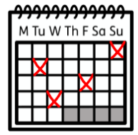 | Upcoming dates/events | 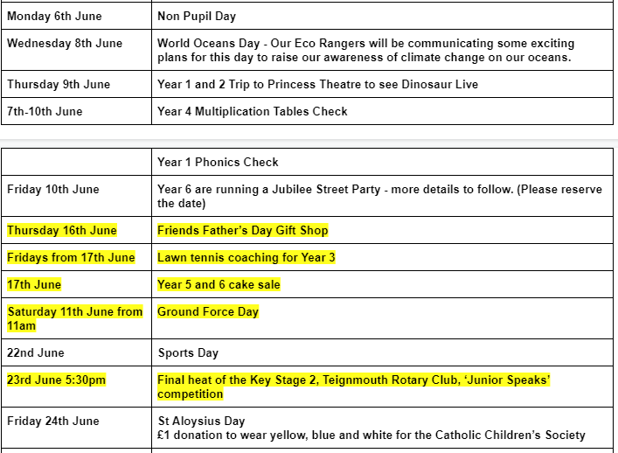  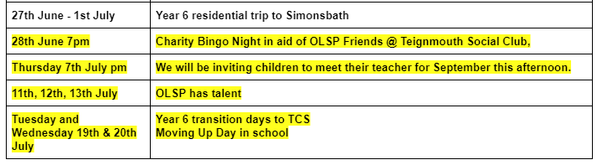
 | Teacher contact: | aokane@olsp.uk  There will also be a message board outside of class one for any messages you wish to leave or I am available via class dojo.  Please note that teachers are teaching from 8.30am - 3.15pm. If your contact is urgent please contact the school office office@olsp.uk during the school day.  There is no requirement for a teacher to reply to emails received after 6pm or at the weekend.

