Our Lady and St Patrick’s RC Primary School

Autumn 2 Curriculum Newsletter

Class 4 Autumn 2

 | Teacher’s Message | Hello to all of the lovely parents and carers to the children in Class 4! I hope all of you have had restful and active half term whether you have been doing different things with your child every day or taken a deserved break.  Please read on to find out about all the new and exciting learning which Class 4 and I will be getting up for the second part of this autumn term leading up to Christmas.
 | Homework | Set on Class Dojo every Friday:  Spellings: Weekly spellings will consist of a list of 10 words with the Year ¾ statutory spellings list.  - Weekly Spelling Tests will take place on Fridays.  - Please make sure your child is practising their spellings as much as possible.  Maths: IXL activities linking to our classroom learning.  Please also try and practice your timetables for the Multiplication Tables Check using ‘The Maths Factor Timetables Check’ and TTRockstars. I have started to add additional links of times tables (7s, 8s, and 12s times tables). Despite the multiplication check won’t be happening till later on in the academic year, the earlier this is started and the children are practicing the better!  Reading: Children will be asked to take home their AR books home from school daily. You should try to at least read with your child for at least 5 minutes. They can then quiz on these in school on ‘Accelerated Reader’.  Homework will be set on Class Dojo on Friday after school and be due the following Friday.
 | Reading for Pleasure | 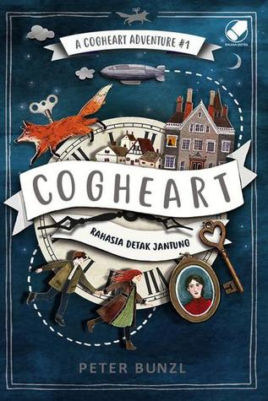  For this half term we will be reading ‘Cogheart’ by Peter Bunzi. I have been told by some of the children in the class have already read this book already. This will which will be great for a lot of the children to reminisce on a previous story together and of them to reminisce on a previous story and enjoy it together as a class.
 | English | In English we will be completing our non-chronological reports. Near the end of the Autumn 1 term, Class 4 were looking closely at the Storm Unicorn text and eventually working towards creating their own independent pieces on an animal of their choice.  Eventually once we have finished our non-chronological reports, Class 4 will then be exploring Myth Atlas by Thiago de Moraes. We will be exploring this text for its nouns and pronouns as well as fronted adverbials to improve our sentence structures for when the children start to write their own independent pieces.
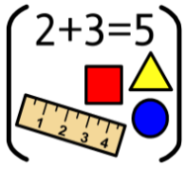 | Maths | Throughout this term in maths, we will be completing our learning when focusing on subtraction with numbers when using the column method. We will then be applying our thinking surrounding perimeter as to what perimeter means and how it is applied to maths. Once perimeter is finished, we will be looking at multiplication and division. We will be securing our understanding when multiplying and dividing numbers by 1, 10 and 100 as well as looking at various times tables.
 | RE | Through this term in RE, Class 4 will be focusing their attention on two different topics. To start the new term, we will be using the Come and See programme and looking at the topic Called. This topic of knowledge will surround how God invites people to share his life and his work. After we have looked at the topic Called, we will then be diving into Gift. This topic of learning will be focusing on how Jesus was the Gift that was given to us by God and accepted through God’s expression of love to us.
 | Science | This term in science we will be looking at the states of matter surrounding solids, liquids and gas.
 | History | For history this term, Class 4 will be placing their attention on Ancient Greece. As a class will be looking at different periods in Ancient Greece as to how they have affected our everyday lives today and what legacy they left behind. We will primarily be focussing on Alexander the Great and Ancient Greek culture as to what life was like back in 700 BC.
 | Geography | Not a lead subject this term.
 | Art | Not a lead subject this term.
 | Design Technology | This term in Design and Technology, Class 4 will be preparing and building their own sandwiches thinking about which fillers will be most suitable for their sandwiches. This will be covered by Mrs Emmerton during PPA on Thursday’s.
 | RSHE | Within this unit of RSHE, we will be continuing our learning on Habits with how we can stay healthy and look after our bodies.
 | PE | During PE this term our focus will be on football. I am excited for this topic during PE and I know a lot of the children will be excited also. Throughout PE, children will be looking at different skills which will range from passing, controlling a ball, attacking and defending as a unit. The other topic of focus of PE will be handball which will be taken by Mr Selley on Thursday afternoons. PE will continue to stay on Wednesday and Thursday for Class 4 pupils.
 | Music | In music this term, we will be specifically focusing on the song – Mamma Mia by Abba.
 | MFL (Y3+) | In Spanish this term, we will be learning and thinking about family members. This subject will be taught by Mrs O’Sullivan in the later part of the Autumn 2 term.
 | Computing | Not a lead subject for this term.
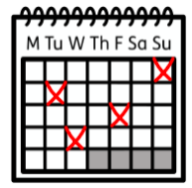 | Upcoming dates/events | 31st October Inset Day for staff, school closed for pupils.  1st November All Saints Day – Mass in the school shall at 10am  4th November Wear Caps for Cash – to raise money for CCRS  8th November Phonics workshop for parents in the EY Unit. All parents invited, no matter what phase your child is at.  8th November Year 5 - Explore the Orchestra Workshop - Bournemouth Symphony Orchestra  16th November Year 5/6 World Cup Style Football Tournament  17th November Selected Play Leaders Training  13th December Reception/Nursery Nativity  16th December End of Autumn term
 | Teacher contact: | Please note that teachers are teaching from 8.30am - 3.15pm. If your contact is urgent please contact the school office office@olsp.uk during the school day.  There is no requirement for a teacher to reply to email received after 6pm or at the weekend.

